**Assignment**: (Spring MVC) - Assignment ID: 14_SpringTest_Assignment1

convert the application developed in (10_Spring_Assignment4) to a spring boot application

Develop Web application to facilitate the below operations using Spring Web MVC Integrating with Spring Data and add search book by title and search subject by duration operations using custom queries

a. Add a Book

b. Delete a Subject

c. Delete a book

d. Search for a book

e. Search for a subject

f. Search book by title

g. Search subject by duration

**Code**:



**Web Page Screenshots (Angular and Spring Boot - Spring Data)**:

**Subject Book List**

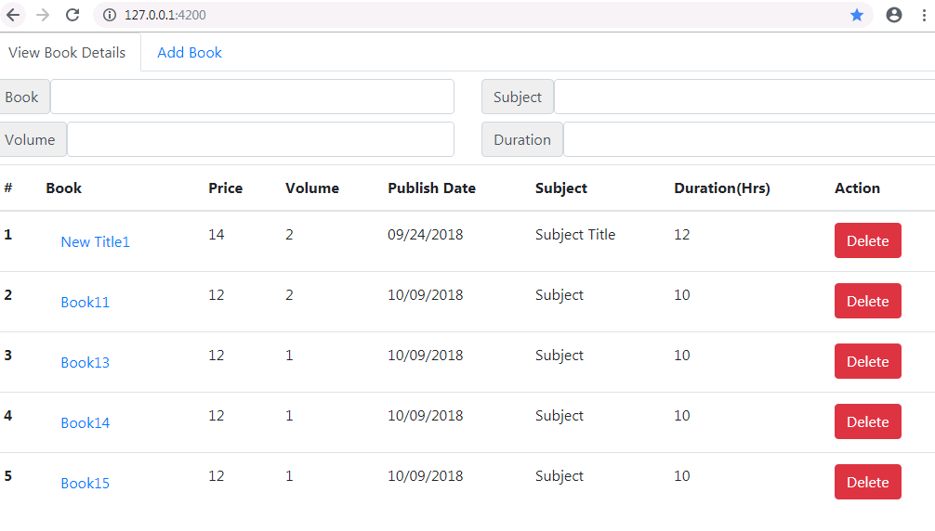

**Subject Book Add Page**

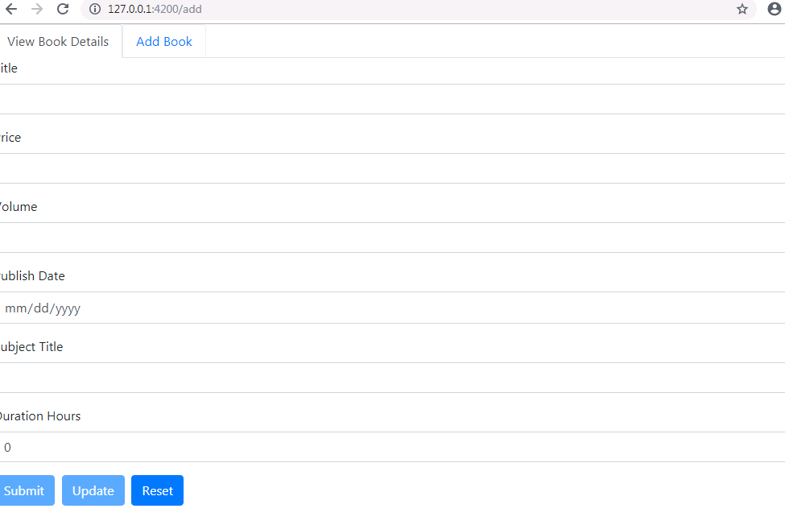

**Search using Book**

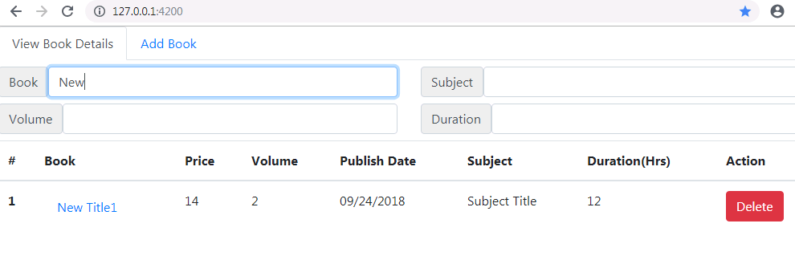

**Search using Subject**

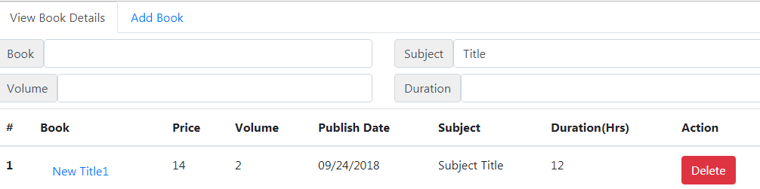

**Search using Volume**

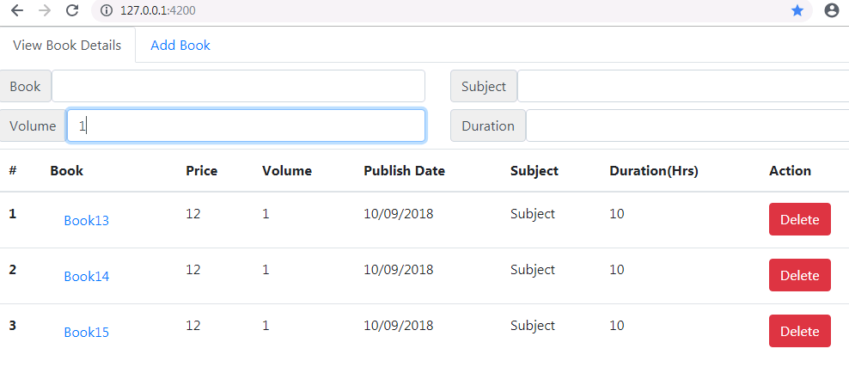

**Mongo DB Command prompt**

